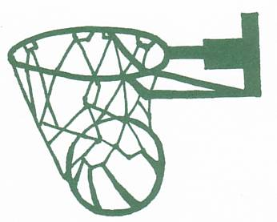
Randwick Netball Club

Registration form

First Name:
Last Name:

Date of Birth:

Home Address:

Home Telephone No:

Email Address:

Positions Played:

Emergency Contact Details
Name:

Relationship:

Address (if different from above):

Contact Telephone Numbers:

Do you have any disabilities? |  | YES | NO | Would rather not say
If you have any medical conditions that you would like us to know about, please supply info
If there is anything we can do to support you with disabilities/medical conditions, please provide details here |  | (e.g.: a buddy, sign language / lip reading awareness, different coloured bibs and balls, benches for easy access to inhalers on court, etc.)
Name of family Doctor:

Doctor’s Telephone No:

Declaration
- I agree to abide by the rules of the club.
- I understand that whilst coaches and personnel leading the activities will take every precaution to ensure that accidents do not happen, they cannot necessarily be held responsible for any loss, damage or injury suffered by myself.

Signed: ………………… Date ……………….

Name (please print): ……………….

