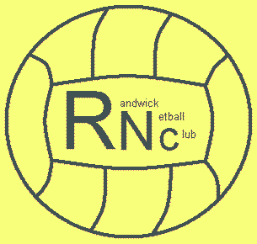
Guidelines for dealing with an Incident/Accident
Insert club logo

- Stay calm but act swiftly and observe the situation. Is there danger of further injuries?
- Listen to what the injured person is saying.

- This form is used by the club in case of accidents and emergencies that occur during club activities as a report of the incident that has taken place and any follow ups that may be required this form is the evidence base for procedures. Please see our Health and Safety Policy for our commitment to members and a list of our qualified first aiders dealing with incidents and accidents.
- In the first instance where an incident occurs please consult the coaches present and health and safety officer who will be able to make a copy of the incident form available and discuss any actions necessary
- Our club policy is contained within our Health and Safety policy to treat incidents with the most appropriate course of action for all club members which may include: (but is not exhaustive) injured players sitting out at training to manage incident, delay of training to manage incident, suspension of training or removal of individuals to manage incident and reporting incidents to the venue.
- The most appropriate actions will be assessed by the Health and Safety officer, first aiders and coaches delivering the club activity.

- Alert the first aider who should take appropriate action for minor injuries.
- In the event of an injury requiring specialist treatment, call the emergency services.
- Deal with the rest of the group and ensure that they are adequately supervised.
- Do not move someone with major injuries. Wait for the emergency medics.
- Contact the injured person’s parent/guardian.
- Complete an incident/accident report form.

Incident/Accident Report Form

Venue |  |  |  |  | Location of  accident/incident
Date of accident/incident |  |  |  |  | Name of individual(s) who  dealt with the accident/incident
Nature of accident/incident

Details leading up to the accident/incident

Details of all club members involved

Details of action/events after the
accident/incident

Give full details of action taken during any first aid treatment and the name(s) of first-aider(s).

Were any of the following contacted? |  |  |  | Parents/carers Yes No  Police Yes No  Ambulance Yes No
What happened to the injured person following the incident/accident? e.g. carried on with session, went home, went to hospital etc.

All of the above facts are a true record of the accident/incident
Print name
Signed |  |  |  |  |  | Date

